Protein sequence analysis
Abstract
This project involves DNA/protein sequence analysis using bioinformatics tools. Protein sequences were retrieved from the UniProt database and analyzed using NCBI BLAST. The analysis identified similar protein sequences and evolutionary relationships among organisms. Important parameters such as sequence identity and E-value were studied. The results showed high sequence similarity and functional conservation among proteins.
Introduction
Uniprot
UniProt Consortium (Universal Protein Resource) is a major protein database used in Bioinformatics. It stores information about protein sequences, structure, and functions.UniProt contains two main sections: Swiss-Prot (manually reviewed protein data) and TrEMBL (computer-annotated protein data).It provides details such as amino acid sequence, protein function, enzyme activity, biological pathways, and protein interactions.UniProt is widely used for protein identification, sequence analysis, functional annotation, genomics, proteomics, and drug discovery research.It is a free and regularly updated database that supports researchers in biological and computational studies.
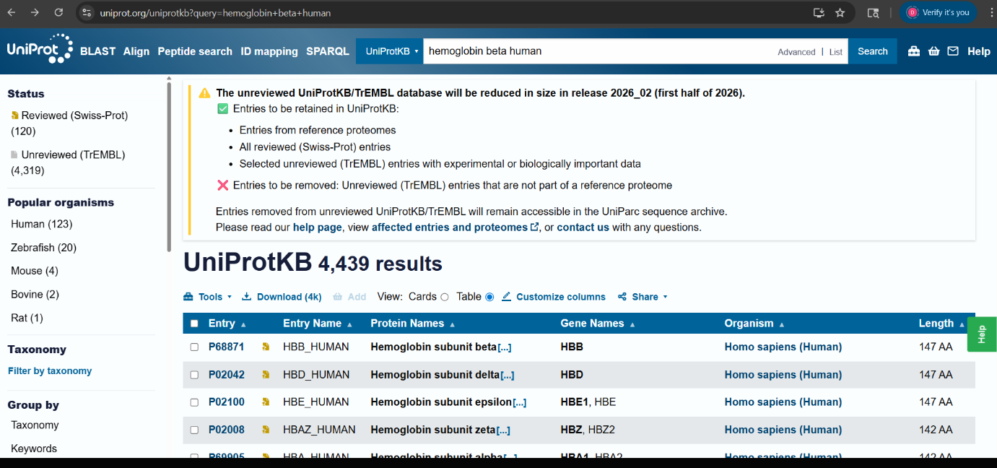
Fig1: - Uniport protein searching.
Blast
BLAST stands for Basic Local Alignment Search Tool. It is a widely used bioinformatics program that was first introduced by Stephen Altschul BLAST is a powerful tool for analyzing biological sequence data. Since the initial release of BLAST in 1990, it has undergone continuous updates to improve its speed and accuracy. BLAST is now considered a crucial and widely used tool in the field of bioinformatics. It has played a vital role in numerous research studies and has paved the way for the development of other sequence comparison tools.
MATERIALS AND METHODS
Data Collection
Protein sequence data used in this study were collected from the UniProt database. The selected protein sequence was obtained in FASTA format for further analysis.
Sequence Retrieval
The protein sequence was retrieved from UniProt by searching the desired protein entry and downloading the corresponding FASTA sequence.
BLAST Analysis
The retrieved FASTA sequence was analyzed using the BLASTP tool available at NCBI. The sequence was compared against the non-redundant protein database to identify similar protein sequences and homologs.
Parameters Analyzed
Important alignment parameters such as sequence identity, query coverage, alignment score, and E-value were examined to evaluate sequence similarity and significance.
Result Interpretation
The BLAST results were interpreted to study sequence similarity, protein function, and evolutionary relationships among related proteins.
Results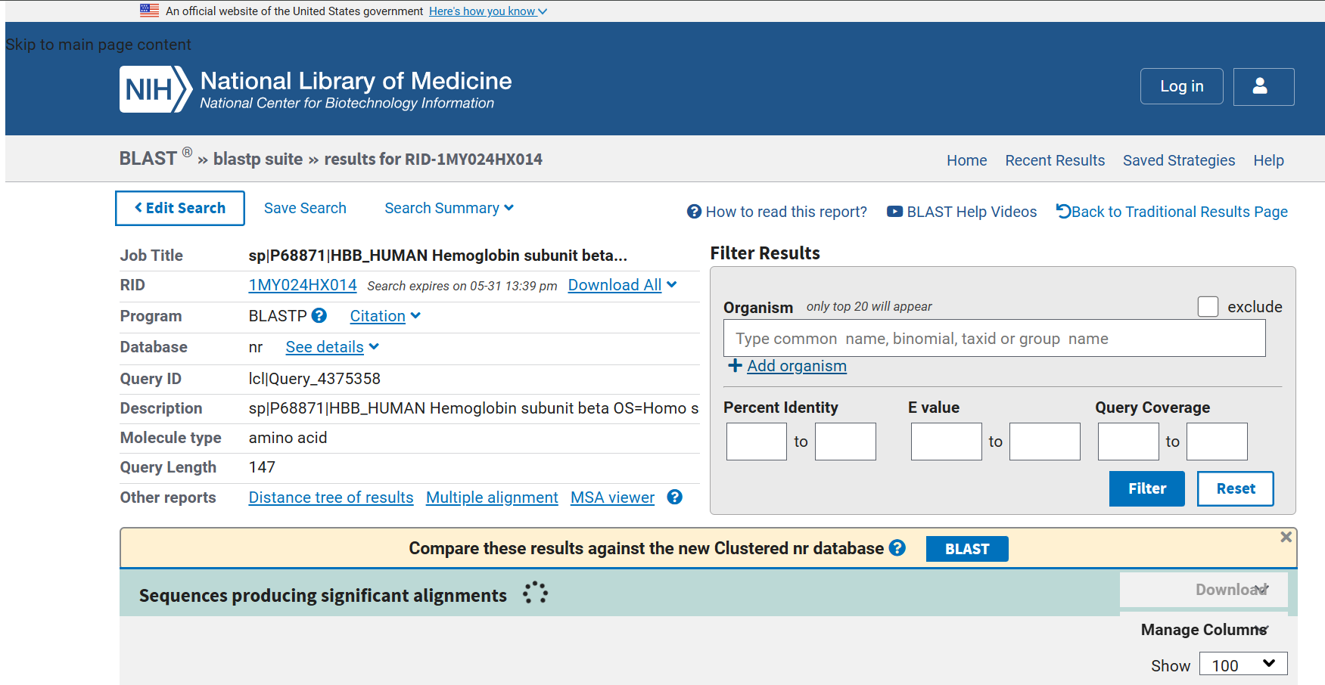
Fig2: - BLASTP output.

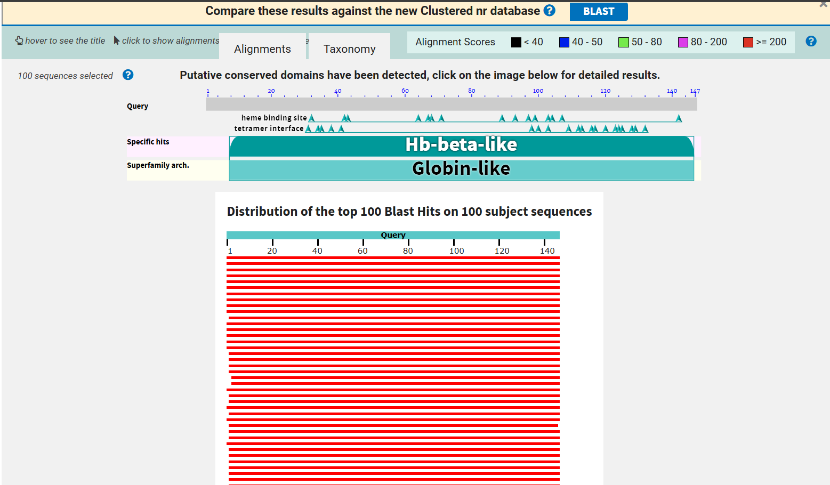
Fig3: - Graphical representation.
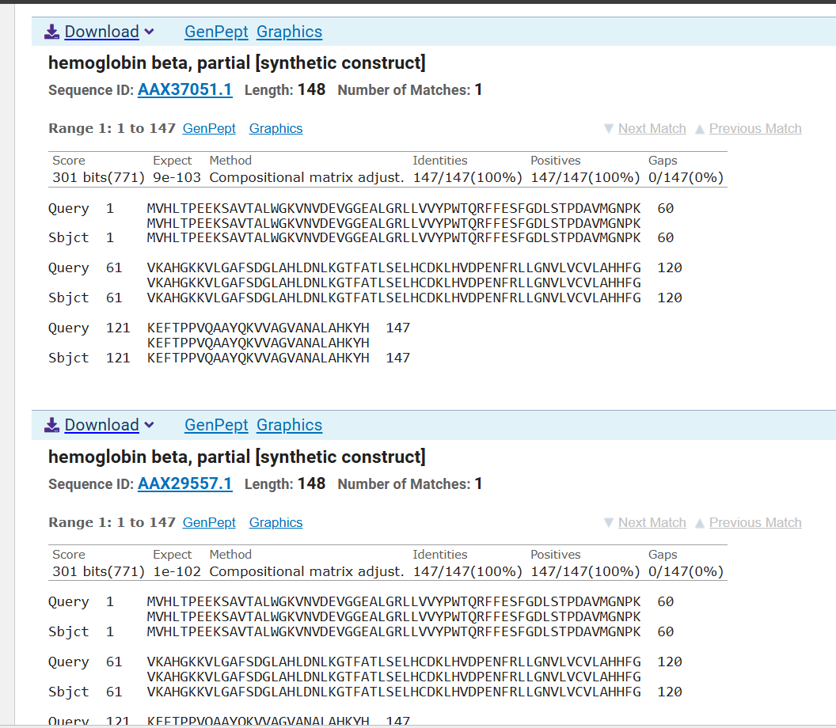
Fi4: - Alignment.
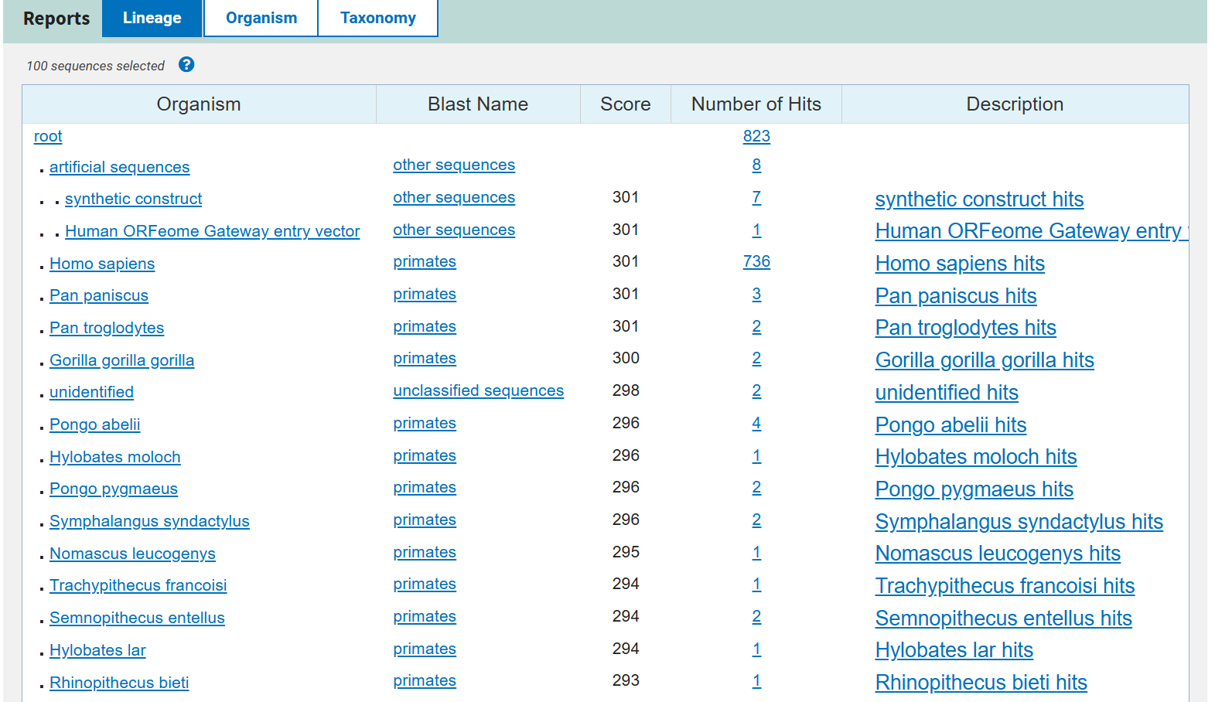
Fig5: - Taxonomy.
PROTEIN SEQUENCE ANALYSIS OF HEMOGLOBIN PROTEIN USING BLAST
Submitted by:
Disha Chandrakant Annapure
Internship domain:
Bioinformatics internship

